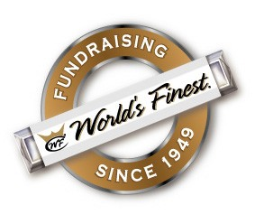DEAR PARENTS,

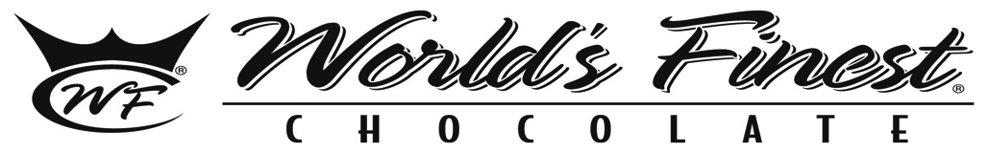We are excited to announce an upcoming fundraiser featuring

This year we are having a Choral fundraiser to help cover the cost of student activities.

We hope you’ll support our school by getting involved with this fundraiser.

* Each bar costs **$1.00** … so you’ll collect $60 per box sold – we keep 50%!
* Each variety box contains:

12 almond bars

18 caramel bars

12 crisp bars

12 milk chocolate bars

6 dark chocolate

50% of all sales remain with our school!

1. Complete Permission Form
2. Sell 60 bars
3. Return $60

**3 EASY STEPS**

*\*I understand I will be responsible for turning in $60 per box checked out —chocolate may not be returned.*

**I also understand that all chocolate MUST BE SOLD OFF CAMPUS (or 30 min after the end of the school day)

Sale Begins: day, date

Sale Ends: day, date

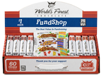

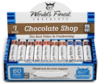

Grade

Signature

Teacher

Student Name

Phone #

I understand I will be responsible for turning in $60 per box checked out.

Chocolate may not be returned.

Yes, I want to check out 1 box of chocolate.