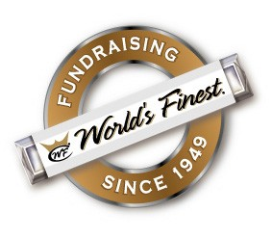

YOUR SCHOOL/GRADE/CLUB

WORLDS FINEST CHOCOLATE BAR FUNDAISER TO SUPPORT YOUR STUDENTS TRIP TO

DESTINATON/EVENT

Dear Parents:

This year’s 5th Grade field trip is to XXXX from XXXX thru XXXX.

We are pleased to offer a terrific fundraising opportunity to help support your child’s trip cost of $XXX.

A great fundraiser, the World’s Finest Chocolate Bars $1 Bars!!

* **ALL PROFITS RAISED GOES DIRECTLY TOWARDS YOUR STUDENTS ACCOUNT -- $30 PER BOX!**
* Each bar costs **$1.00**
* Each variety box contains: 12 almond, 18 caramel, 12 crisp, 12 milk choc & 6 dark chocolate

**SELLING XX BOXES WILL PAY 100% OF YOUR STUDENTS TRIP COST**

**(when you sell more than XXXX boxes, you are helping students in need)**

**3 EASY STEPS**

1. Complete Permission Form
2. Sell 60 bars
3. Return $60 and your account is credited $30

*\*earn $30 credit for each box sold!*

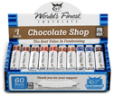

Grade

*I understand I will be responsible for turning in $60 per box checked out —chocolate may not be returned.*

Signature

Teacher

Student Name

Phone #

I understand I will be responsible for turning in $60 per box checked out.

Chocolate may not be returned.

Yes, I want to check out 1 box of chocolate.